TODO: Title Page

Testing
# | Test Name | Test Description | Tools | Pass/Fail | Figure
1 | Config files work | Configuration files are read in and parsed properly | portforwarder.exe  Terminal | Pass | Fig. 1
2 | Invalid configs entries ignored | Configuration entries that are invalid aren't read into the portforwarder | portforwarder.exe  Terminal | Pass | Fig. 1
3 | Receives raw sockets | Portforwarder recieves raw sockets from host | Portforwarder.exe  wireshark | Pass | Fig. 2
4 | Portforwarder sends to target | Portfowarder forwards raw socket to target machine | Portforwarder.exe  wireshark | Pass | Fig. 3
5 | Portforwarder changes IP addresses | Portforwarder changes the source and destination IP addresses in the IP header | Portforwarder.exe  wireshark | Pass | Fig. 3
6 | Portforwarder changes TCP ports | Portforwarder changes the source and destination ports in the TCP header | Portforwarder.exe  wireshark | Pass | Fig. 3
7 | Multiple hosts can connect (same service) | Multiple hosts can connect to the same target machine's service | Portforwarder.exe  wireshark | Pass | Fig. 4
8 | Multiple host can connect (different services) | Multiple hosts can connect to different services on the target machine | Portforwarder.exe  wireshark | Pass | Fig. 5
9 | Host cannot connect to wrong port | Host cannot connect to a non-forwarded port on the portforwarder machine | Portforwarder.exe  wireshark | Pass | Fig. 6
10 | Single host connects to multiple services | A single host can connect to a target service multiple times without any interference. | Portforwarder.exe  wireshark | Pass | Fig. 7

Figure. 1
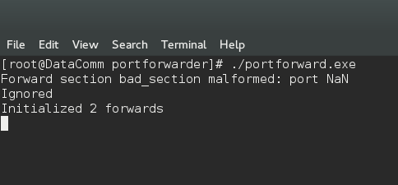

Figure. 2
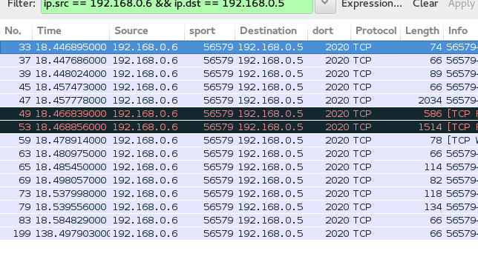

Figure. 3
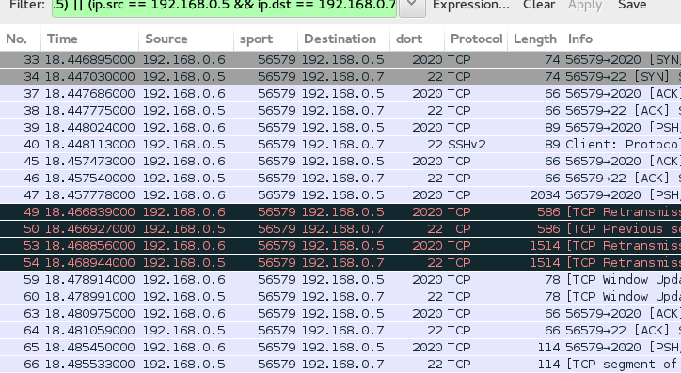

Figure. 4
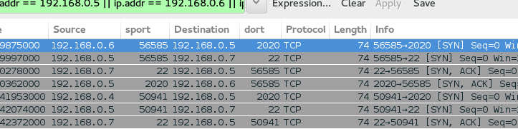

Figure. 5
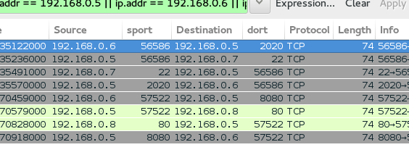

Figure. 6

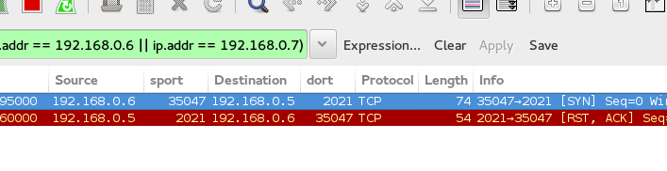
Figure. 7
